Setting RunGate & Selgate

* Game Gate Server #1~4

A. Rungate
1. Add New Folder

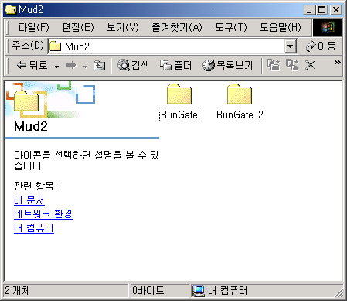
Add New Folder

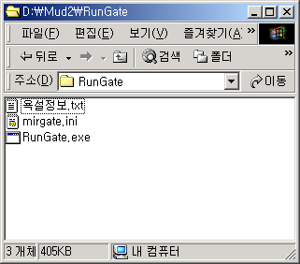
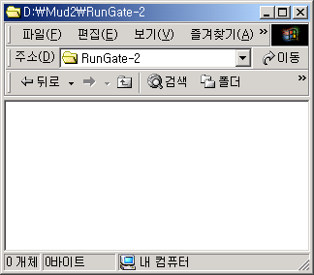
2. Copy Files to New Folder
Copy Files
3. Edit mirgate.ini file
Original Port
After Editing

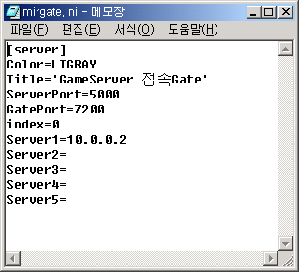
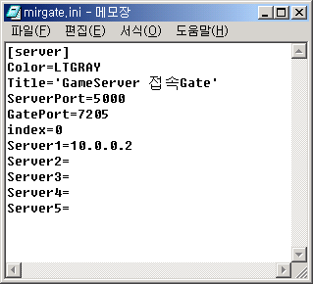
Private Server
Address
위와 같은 방법으로 Rungate(Port 7200 ), Rungate2( Port 7205 )
Server1=10.0.0.2 (Game server#1 IP Address)
Rungate2( Port 7201 ), Rungate2( Port 7206 )
Server1=10.0.0.3 (Game Server#2 Address)
Rungate2( Port 7202 ), Rungate2( Port 7207 )
Server1=10.0.0.4 (Game Server#3 IP Address)
Rungate 는 6개를 Game gate Server 4대 모두에 똑같이 해준다.

B. Selgate

1. Add New Folder
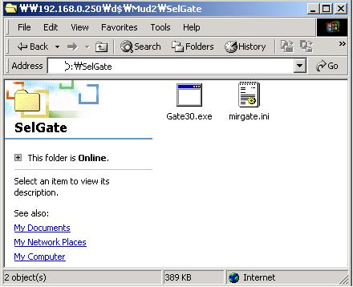

2. Edit mirgate.ini file

[server]
Color=Green
Title='SelChr 접속Gate'
ServerPort=5100
GatePort=7100
index=0
Server1=10.0.0.250 <- Master Game Server(Game Server #1) Private IP Address
Server2=
Server3=
Server4=
Server5=

Game Gate Server #1~4번까지 모두 같은 셋팅입니다.

